Document A

1741 Captain’s Orders to Richard Derby
Original transcription
Richard Derby of Salem was captain of Volant, a ship owned by Salem merchant Benjamin Gerrish. This is an excerpt of a letter (or captain’s orders) Gerrish wrote to Derby in 1741. Gerrish gave Derby instructions for where and how to trade Volant's cargo in the West Indies, and included a request that Derby purchase an enslaved child.
Capt Richard Derby
Our schooner Volant whereof you are
Master being fully laden if you having all things on board
necessary for your Voyage, Our Orders are that you embrace the
first fair wind and weather and come to Sail and proceed for the Is-
land of Barbadoes, where when you arrive (if you think proper
to go in) apply to Mr. Gedney Clark Mercht there, to see if he
according to our Letters to him thh Capt: Orne, has procured a
permitt in Order to your going to any one of the French Islands
to trade, but if he has not affected it, and it is not in his power
to procure a permitt, then make application to any person upon
the Island you may be advised to either for a permitt or Letters
of Recommendation to some person of Distinction at any one of the
French Islands, insuring our Interests there whilst amongst
either the whole or in part, whilst among the French, if you can
do it at what you judge a reasonable Rate; but if after
all you can gett neither a permitt not Letter without selling
your Cargo at a very low rate, and no French war, or in Case
you think it not proper to truck at Barbadoes, then proceed di-
rectly for Martinico or Guadalupe and use the Most prudent
methods you can to Trade; and don’t let your people trade
for any trifle which may bring you under any Difficulty;
and before you leave the Islands, secure a permitt for coming again
and also bring a Memorandum of what will better suit the Markett
than what we now send: but if so unlucky at last as not to
trade with the French, then proceed for the English Islands, and use
your best Endeavors both in the Sale of your Cargo, and Security
of your Vessel against the Hurricanes; unless you can get se-
curity at St. Eustatia or St. Martin’s to go up among the French
or to Cape Francios: Wherever you trade lay out the produce
of your Cargo in such things as you judge will be most to our
Advantage; if you are obliged to trade among the English, we imagine…

Note written on the side:
Capt. Derby If you Trade at Barbadoes
buy me a Negroe boy about Seventeen years
old which if you do advise Mr. G Clarke of it he may
not send one also_______________________
Benj Gerrish jr

Document A

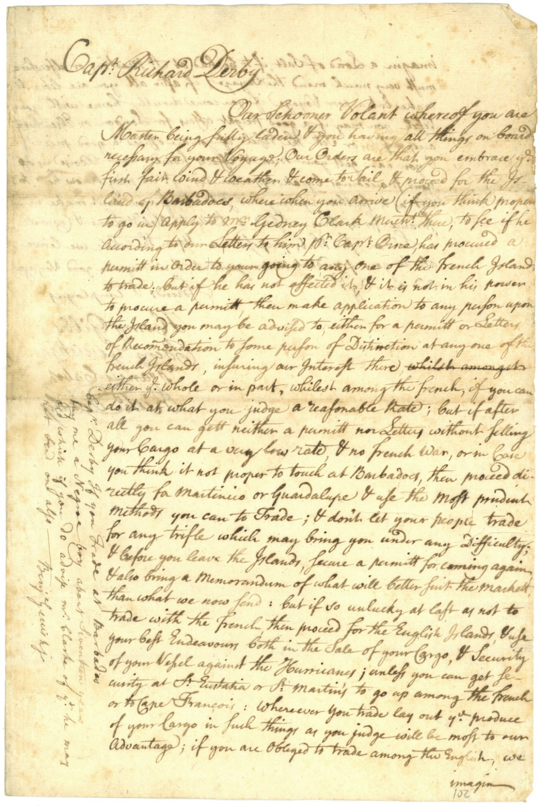

Source
Derby Family Papers, MSS 37, Box 6, Folder 6
Courtesy of The Phillips Library, Peabody Essex Museum, Salem, Mass.

Document B

Account of Sales of Schooner Pembroke

Original transcription
Pembroke was a trading vessel (ship) owned by Richard Derby of Salem. In 1764 Pembroke traveled to the island of Dominica in the West Indies. This is a record of items from New England (listed on the left) sold or exchanged in Dominica. Pembroke returned to Salem with items from Dominica (listed on the right).

Left side
Account of Sales of the Schooner
Pembrock Cargo at Dominico
February thru ag 1764

£ ſ d
By 348 2^{x} & 1/2 of fish at 18/??? 313 .. 13 .. 0
By 9 feat of Boards at 80/?? 36 .. 00 .. 0
By 11 Barrels of Elvives at 24/pr B 13 .. 14 .. 0
By one Barrel of Cod fish at 24/ 1 .. 4 .. 0
By 11 horsses at 20 pound Each 220 .. 0 .. 0
ſ d
By 7 frames at £8 .. 11 .. 5 pr frame 60 .. 0 .. 0
By one thousand of hoops at 60/pr 3 .. 0 .. 0
By 24 Tearses of Rice at 80/pr Pair 96 .. 00 .. 0
By 3 Empty Tearces at 12/pr Pair 1 .. 16 .. 0
By 2 Small Spares at 6/pr Spar .. .. 12 .. 0

£ 745 .. 19 .. .. 0

Errors Excepted
Henry Elkins

Document B

Left side
Account of the Schooner Pembrock
Cargo from Dominico April 27 – 1764
Errors Excepted
Henry Elkins

cwt £ ſ d
To 4 h-^{d} of Sugar Neat 4726 at 33/9pr 79 .. 16 .. 0
To 90 h-^{d} & ½ of molasses at 96/pr h-^{d} 472 .. 16 .. 0
or 96 h-d And 11 Tearses which is 10/14
cwt
To one h-^{d} of Coffey Neat 614 at 9^{d} pr 24 .. 7 .. 0
To Com^{n} on Saales at 5 persent 37 .. 4 .. 0
To Com^{n} of Returnes at 21/2 percent 17 .. 13 .. 0
To the Bill of Disburst ments 114 .. 2 .. 10

£ 745 .. 18 .. .. 10
To 1 h h-^{d} [illegible] at 30/pr h-^{d}

Errors Excepted
Henry Elkins

Document B
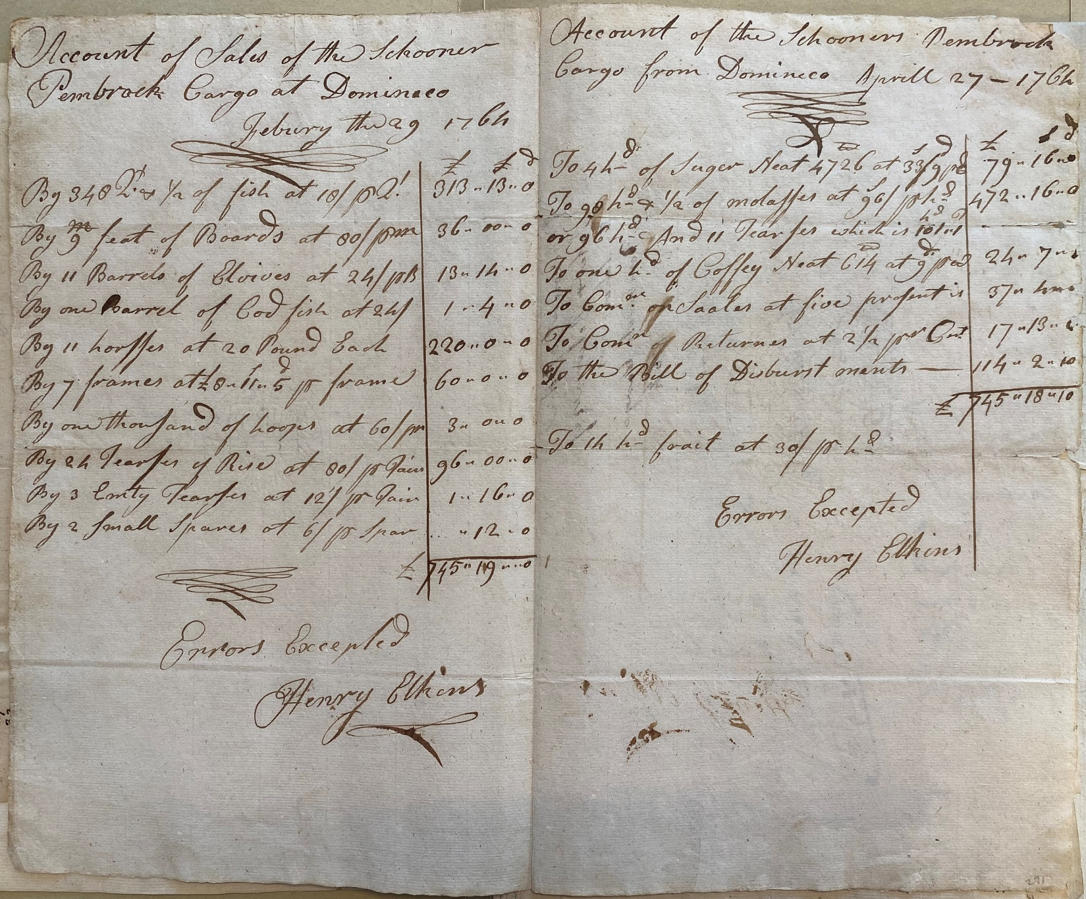

Source
Derby Family Papers, MSS 37, Box 6, Folder 6
Courtesy of The Phillips Library, Peabody Essex Museum, Salem, Mass

Supplemental Primary Source Documents

Document C

A Negro Man Named Jack, Born in Martinique
Original
This “runaway” advertisement was printed in the September 25, 1770 issue of “The Essex Gazette,” a Salem newspaper owned by colonist, Samuel Hall. Advertisements for “runaway” enslaved people and people “for sale” were common and an important source of revenue for newspaper printers.
Runaway from the
Subscriber, on the 17th Inst.
at Night, a Negro Man, nam-
ed Jack, about 6 Feet high,
near 50 Years of Age, speaks
bad English, and born in Mar-
tinico; had on when he went
away, a blue Coat with Mohair Buttons,
a black Jacket with black Glass Buttons,
blue Breeches with white metal Buttons,
and a red ?????? Cap, but may have
changed his Cloaths, as he had more at Be-
verly. – Whoever shall take up said Ne
-gro, and deliver him to Mr. Brown, De-
puty-Sheriff, in Salem, shall have Two
Dollars Reward, and all necessary Charges
paid them.
All Masters of Vessels, and others, are
cautioned against carrying said Negro off,
as they would avoid the Penalty of the Law.
JOSEPH HOMAN.
Marblehead, Sept. 22, 1770.

Document C
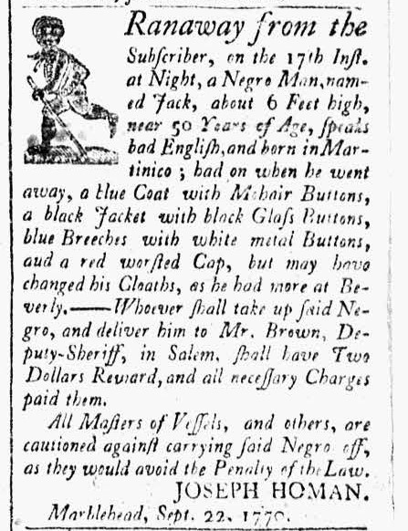

Image Source
“The Essex Gazette”, September 25, 1770. Vol. II, No. 113. Courtesy of Readex: America’s Historical Newspapers. Early American Newspapers, Series 1: From Colonies to Nation.

Document C
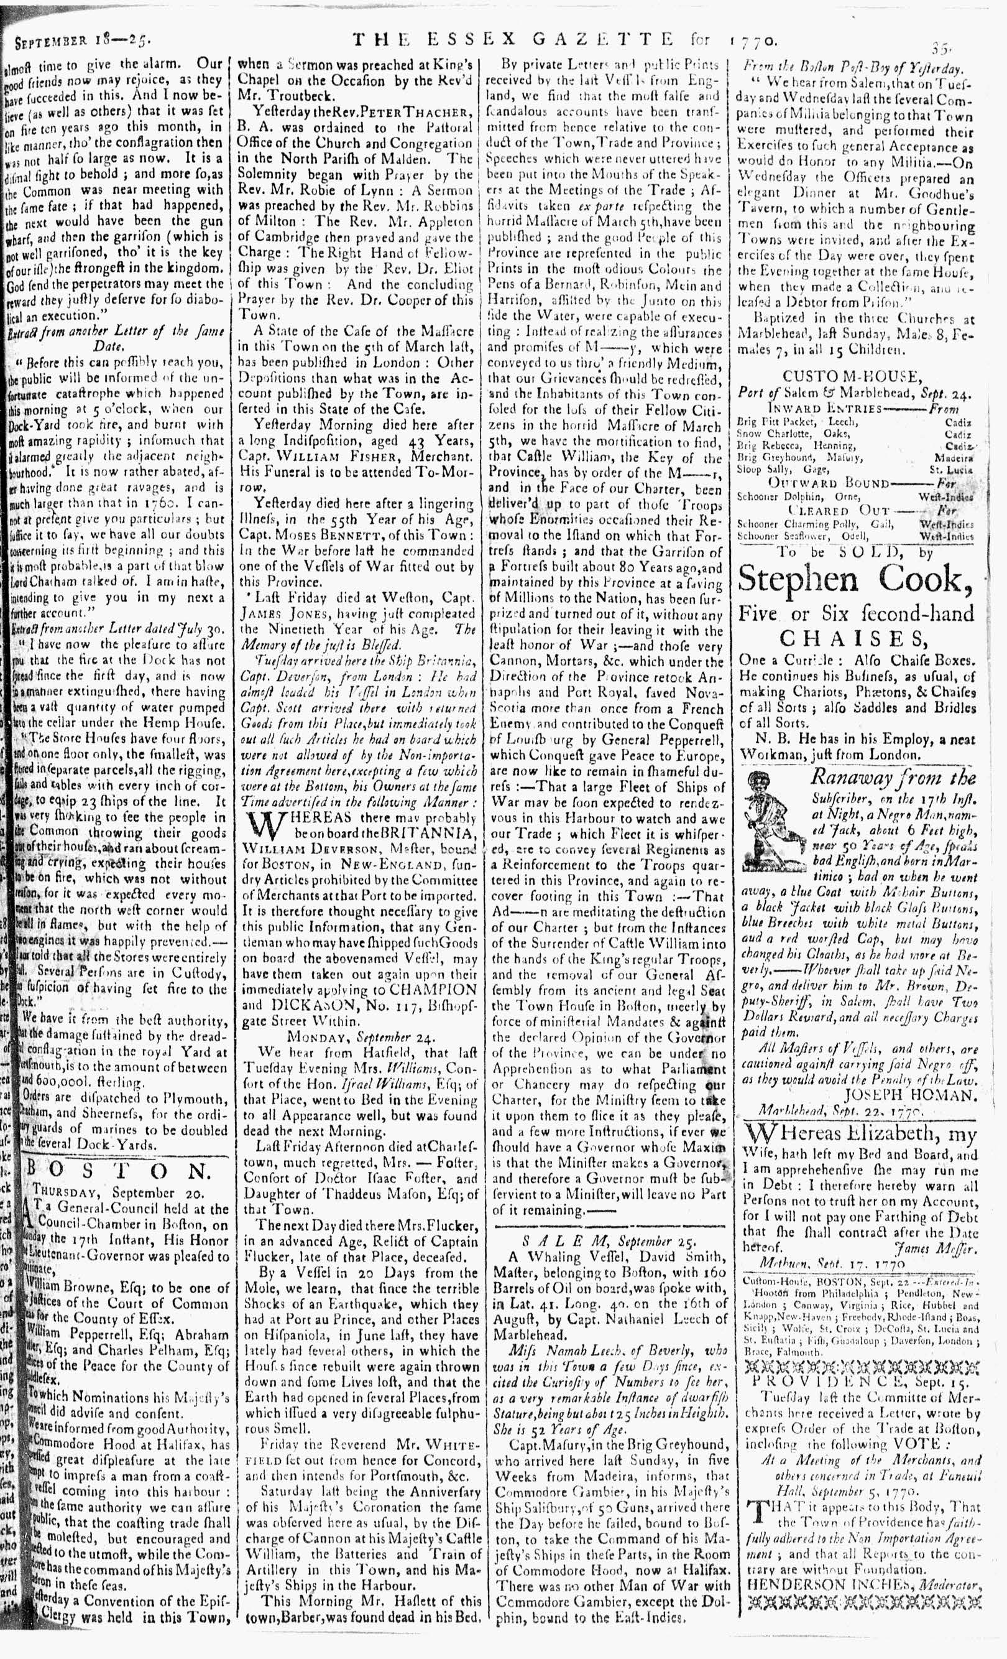

Image Source
“The Essex Gazette”, September 25, 1770. Vol. II, No. 113. Courtesy of Readex: America’s Historical Newspapers. Early American Newspapers, Series 1: From Colonies to Nation.

Document D

Choice Jamaica Sugar & Rum
Original Transcription
Richard Derby Jr. was the son of Salem merchant and ship captain Richard Derby. Like his father, he was a merchant who bought, sold, and traded goods produced on slave plantations in the West Indies. He placed this advertisement in the Salem newspaper, “The Essex Gazette” on October 17, 1769. Underneath appeared a “for sale” advertisement for a teenage boy. He appears to have been trained in woodwork (making barrels) and experienced in field and garden labor.

Just imported, and to be SOLD, by
Richard Derby, jun.
Choice Jamaica SUGAR, RUM,
ALSPICE, GINGER, and Coffee.

To be SOLD,
A Likely Negro LAD, about
eighteen or nineteen Years of Age, works
well at the Cooper’s Trade, and understands work-
ing in the Field or Garden. ---Enquire of the
Printer.

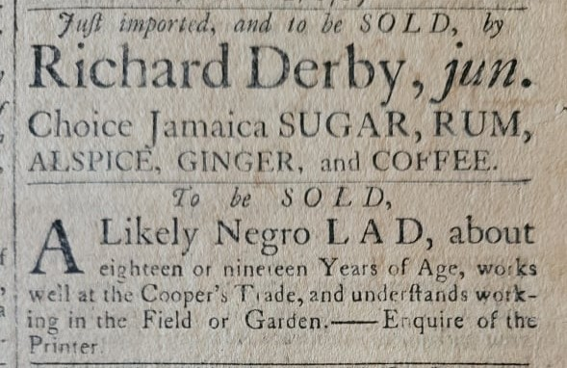

Image Source:
“The Essex Gazette”, October 17, 1769. Vol. II, No. 64. Museum of Printing, Haverhill, MA. NPS Photo.

Document D
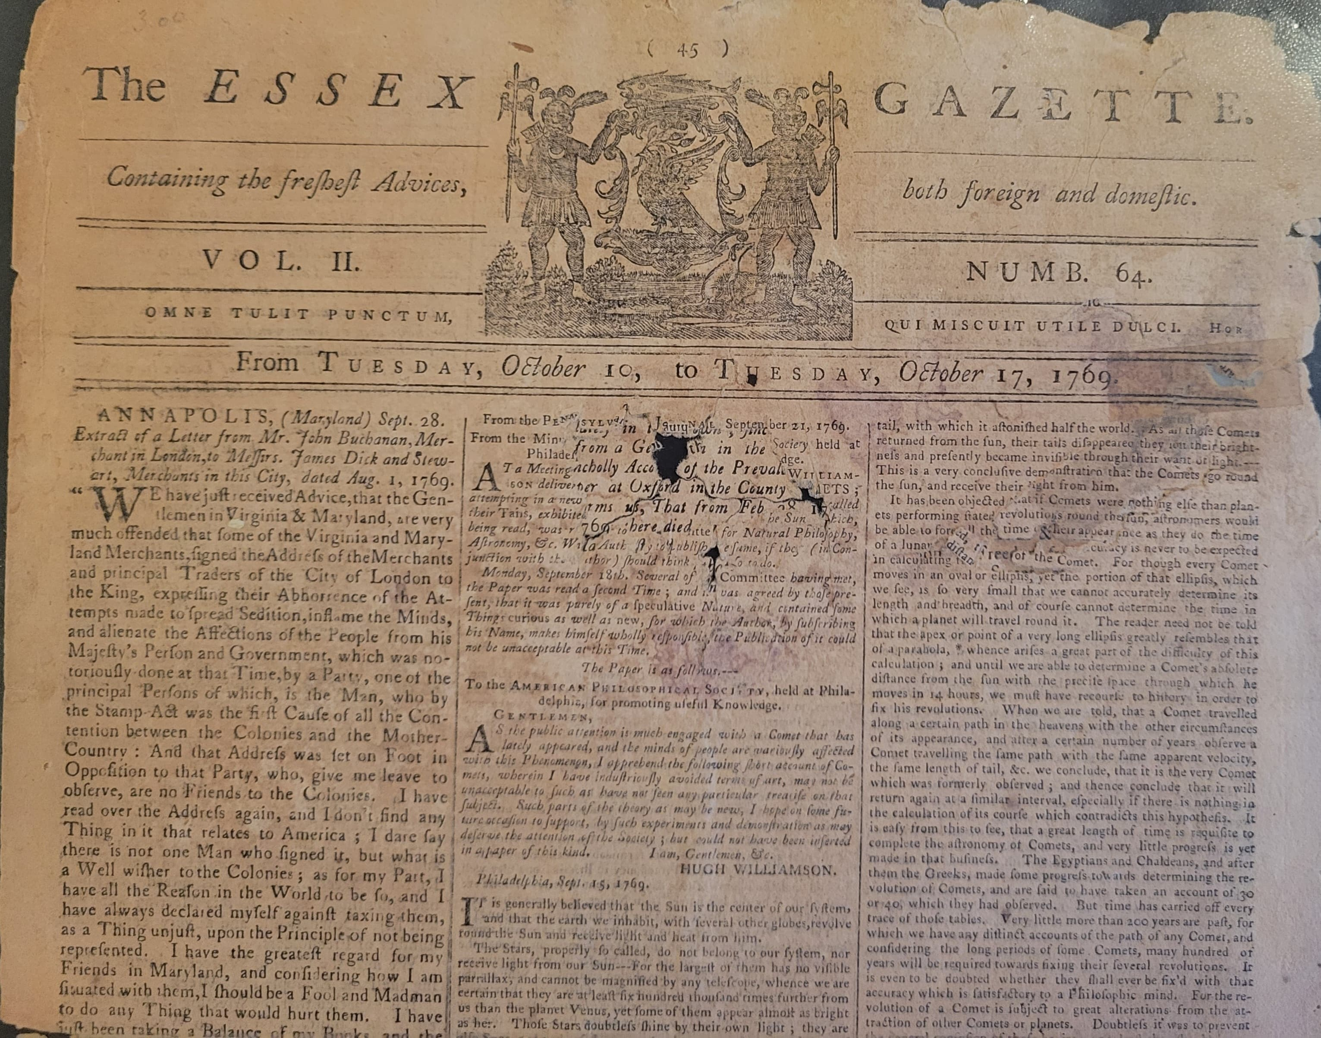

Image Source
“The Essex Gazette”, October 17, 1769. Vol. II, No. 64. Museum of Printing, Haverhill, MA. NPS Photo.

Document E

Map of the West Indies
This 1715 map of the West Indies identifies French, Dutch, Spanish, and English colonies.

Image Source
Moll, Herman, 1732, and Thomas Bowles. A map of the West-Indies or the islands of America in the North Sea; with ye adjacent countries; explaining sic what belongs to Spain, England, France, Holland, &c. also ye trade winds, and ye several tracts made by ye galeons and flota from place to place. [London Printed for Tho. Bowles, 1715] Map. https://www.loc.gov/item/gm71005442/

Document E
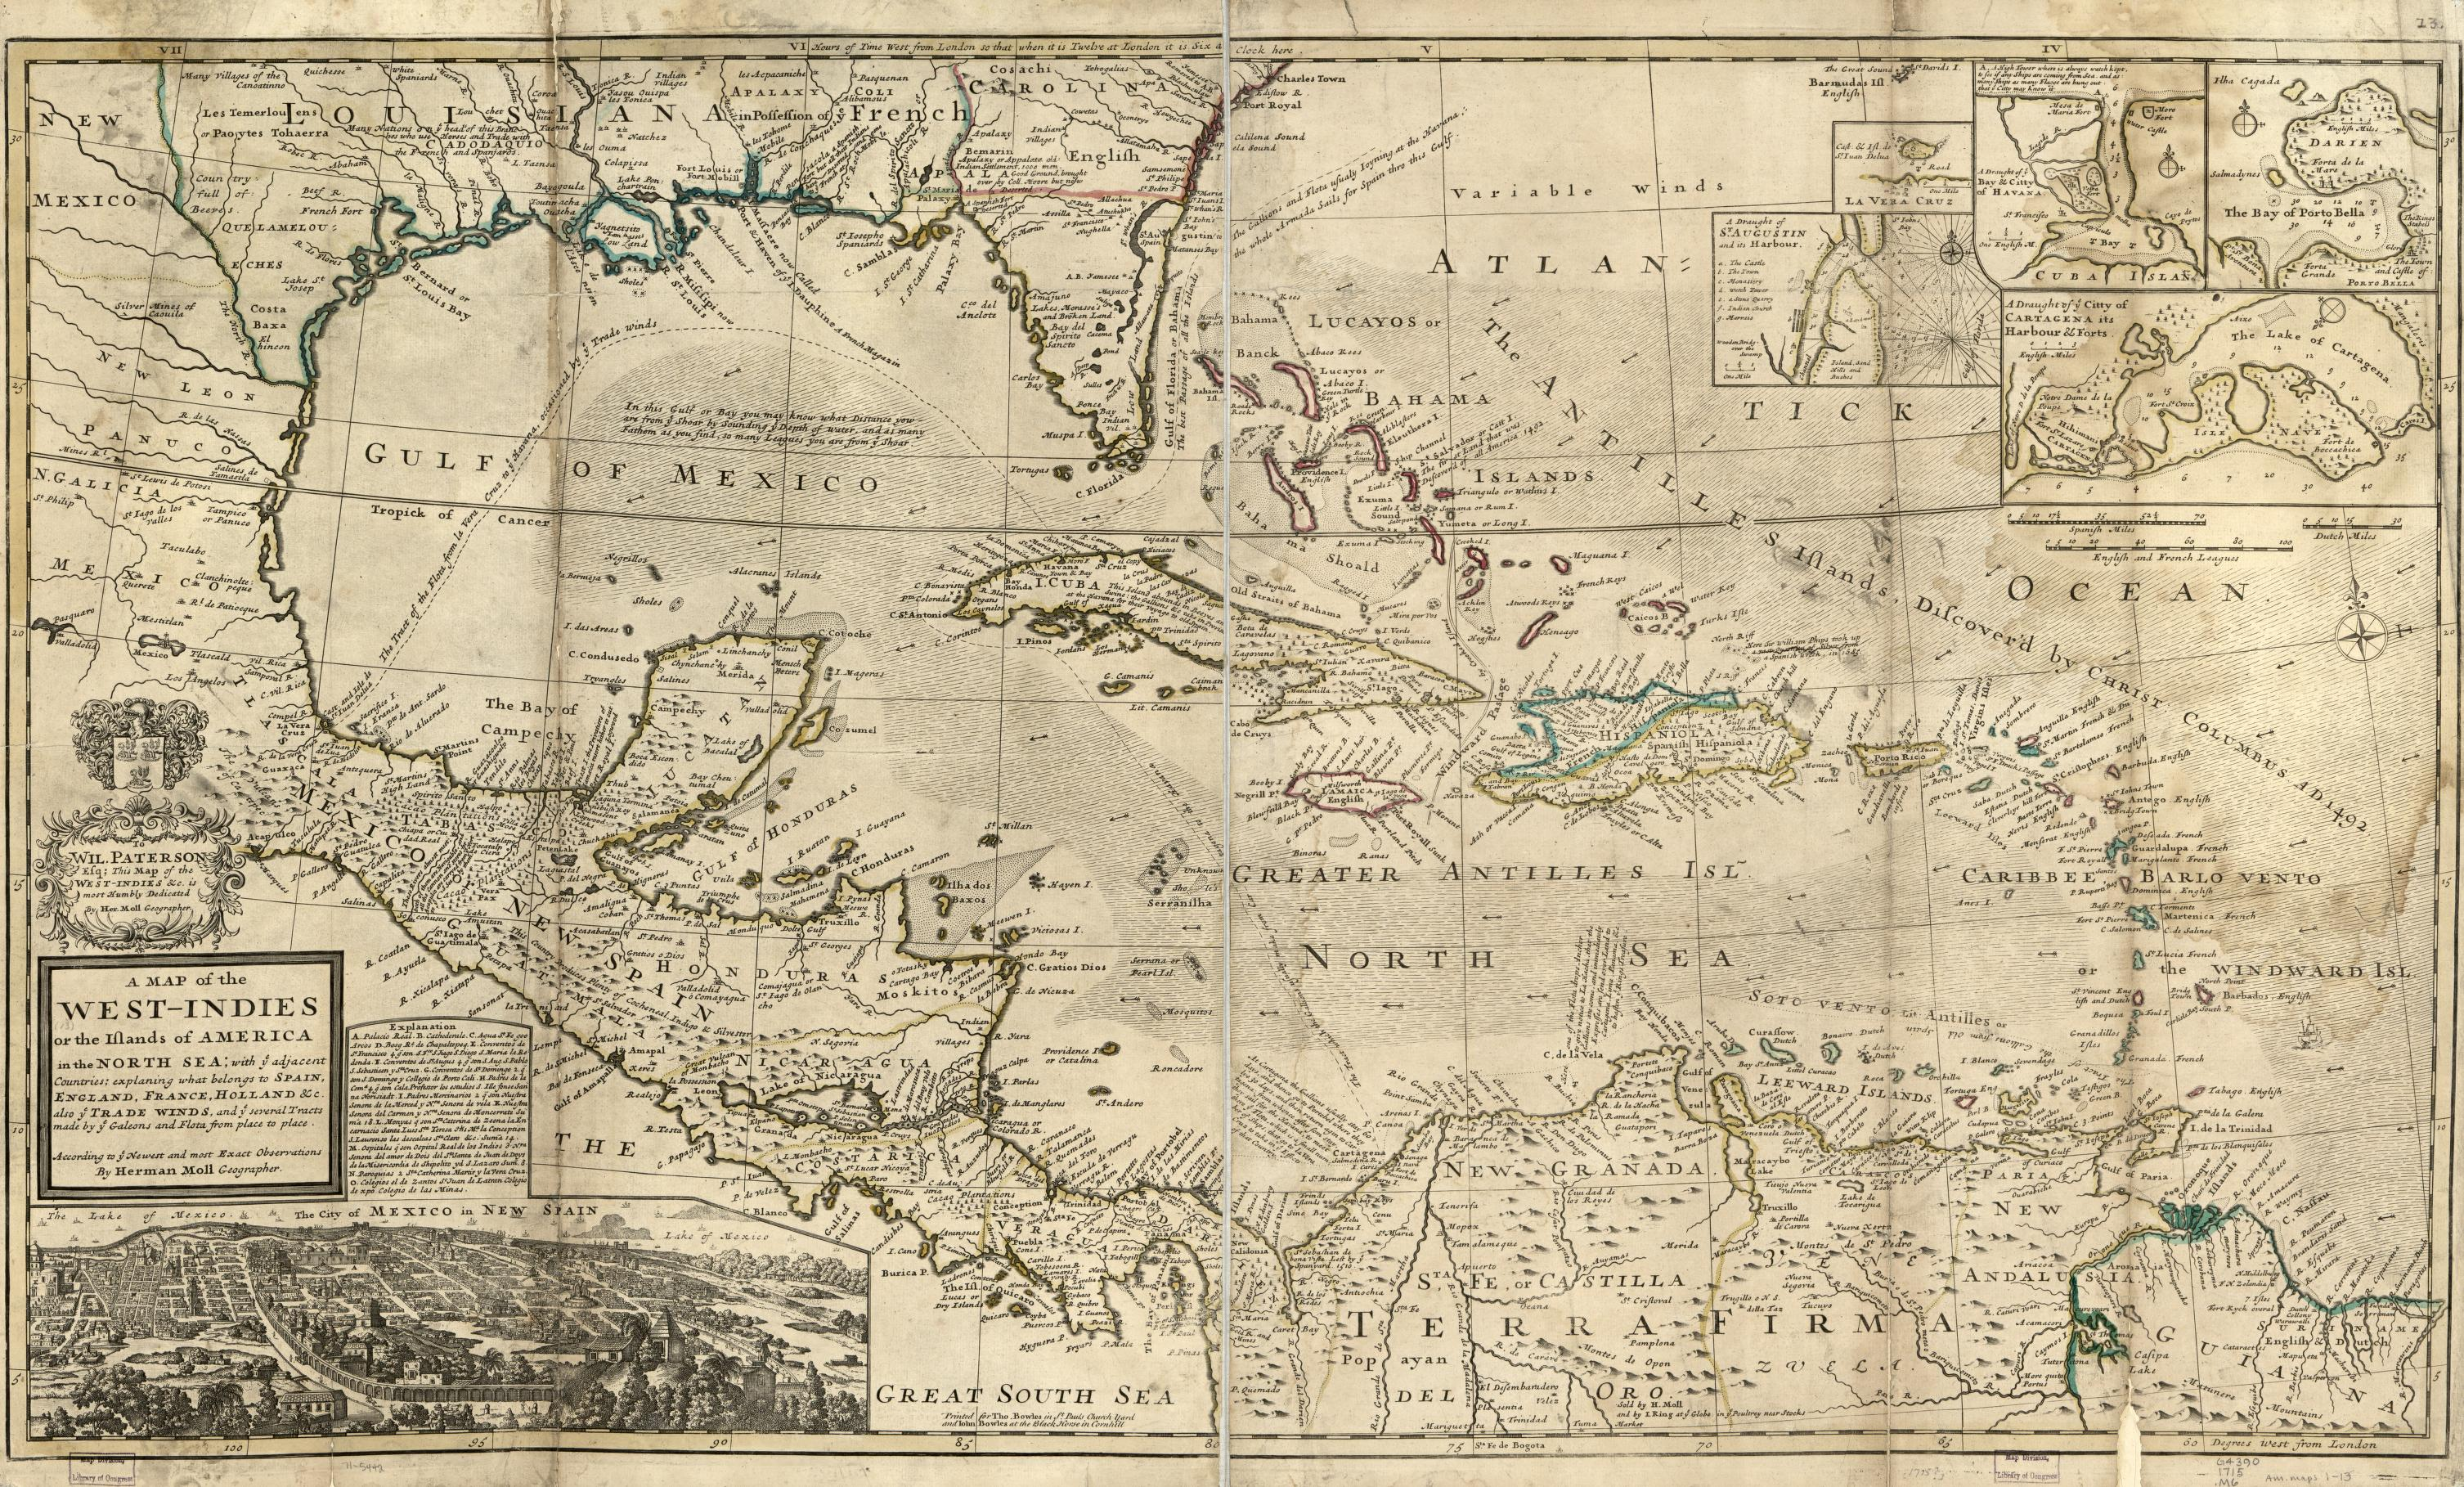

Document F

Cutting Sugarcane
This image is from the 1823 book, “Ten Views in the island of Antigua : in which are represented the process of sugar making, and the employment of the Negroes, in the field, boiling-house and distillery.” This image shows enslaved people (adults, children, and elderly people) cutting and binding sugarcane. Sugarcane, about 9 feet tall, was harvested with sharp, curved knives. Even young children work to bind sugarcane during harvest time. The hierarchy of the plantation is illustrated by the white man looking down from his horse to speak with a Black man, possibly an enslaved overseer, who has removed his hat.
Important note: the purpose of the “Ten Views in the island of Antigua” book and its images was to gain support for slave plantations in the West Indies. Enslaved people were likely not clothed as well as the appear in this image.

Image Source
Clark, W. A. V. (William A. V.), Ten views in the island of Antigua : in which are represented the process of sugar making, and the employment of the Negroes, in the field, boiling-house and distillery/ Ten Views in the Island of Antigua, [London], Thomas Clay, 1823, hand-colored aquatint, Yale Center for British Art, Paul Mellon Collection, [London] : Published by Thomas Clay, Ludgate-Hill, London, 1823.

Document F
